a Pervaiz Lodhie / LEDtronics Inc. Initiative

Pehli Kiran (First Ray of Light):

Poverty Alleviation through
Solid-State LED Technology

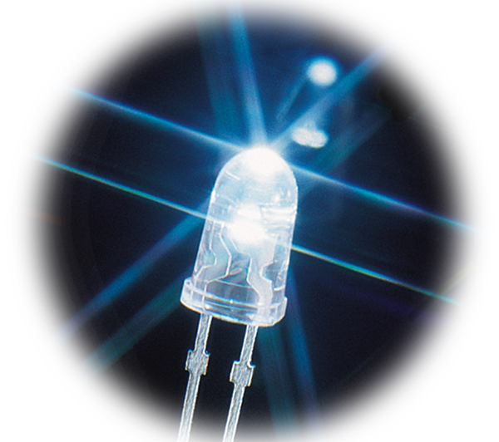

LED Lamps Field Test Report

NRSP Village of Noor Mohd. Turk

Tehsil Matli, District Badin Sindh

Prepared by:

Shahid Siddique

August 26, 2004

A joint project of LEDtronics Inc. USA and Shaan Technologies Pakistan



OFFICIALS

• LEDtronics Inc. USA

Mr. Pervaiz Lodhie
President

• Shaan Technologies

Mr. Shahid Siddique
Managing Engineer

• NRSP

Mr. Rasool Buksh Soomro
Regional Program Manager
Head Office, Hyderabad

Mr. Ghulam Mustafa Haider Jamro
Regional Professional Engineer
Badin Office

REPORT

Lamps were tested in the NRSP Village of Noor Mohd. Turk near Teshil Matli, District Badin.
Mr. Ghulam Mustafa facilitated our communication with the people.

Four 0.4Watt LED lamps were last year 2003 installed in a house. Lamps connected to a 12-volt 12AH sealed lead- acid Exide battery. Battery voltage was 12.16 volts. Another 0.4 Watt LED lamp was used to light the village members' meeting area outside the house. It was connected to the battery by a small gauge wire approximately 80-feet long.

Light levels of the existing four 0.4 Watt LED lamps measured at various distance are given below:

At 1 foot = 24 Foot Candle
At 10 foot = 0.37 Foot Candle

Kerosene oil lantern and kerosene gases light were also being used in the same house. Light level of the kerosene gaslight was 2.2 Foot Candle @ 1 foot. Kerosene lantern provided 1.2 Foot Candle @ 1 ft.

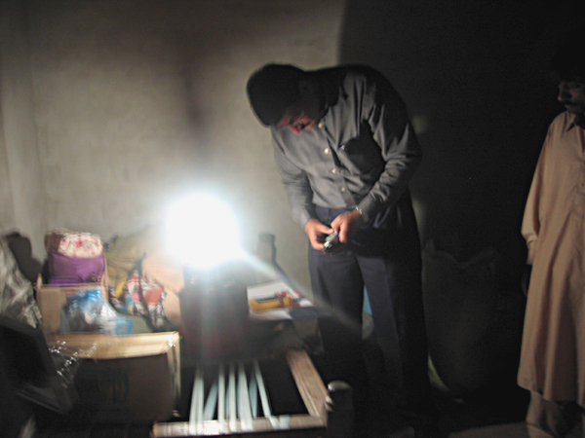
Shahid of ShaanTech holding the Lux / Foot Candle Light
Meter in front of Kerosene Gas Lantern

TEST FINDINGS

Two new lamps were tested here. Test time was after sunset when the location was completely dark. Lamps were tested in both an outside common area and inside a room. Observations for both lamps are given below:

1. S1003-LXW-014W (White LEDs, 3 Watt Energy Consumption, 110 Degree Beam)

Lamp was hung from the ceiling at the height of 8-feet and angled toward floor. Since the lamp is wide angle, the entire room including the roof was illuminated. At 20 feet, the light level was low but sufficient for finding one's way. House members thought this lamp was fine. They can read and work well in this light. Only disadvantage with this lamp was glare. Light levels are given below:

Light level was 2.5 Foot Candle @ 3 Feet

Light level was 1.9 Foot Candle @ 7 Feet

Light level was 0.4 Foot Candle @ 20 Feet

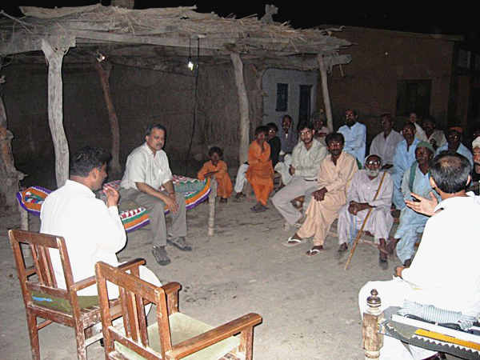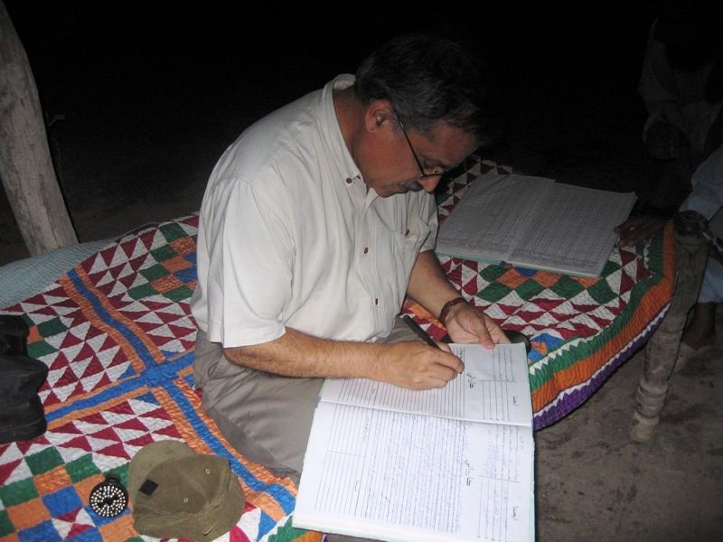
3-Watt Energy LED Bulb illuminating the Village meeting area. Pervaiz Lodhie doing visit comments entry in Village Minutes Book
Pervaiz Lodhie of LEDtronics discussing LED Light with Villagers under 3 Watt Energy LED Bulb.
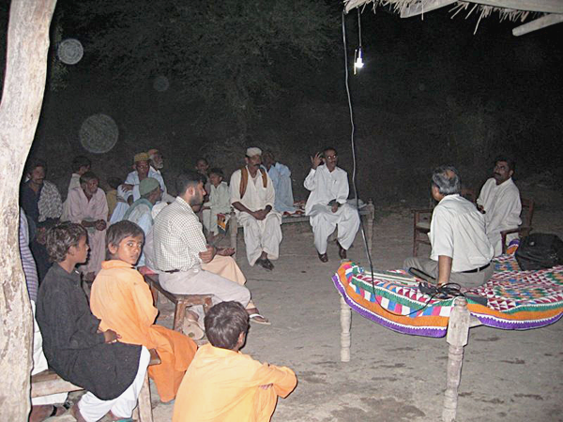
Village Representatives discuss LED Light with Pervaiz Lodhie

2. PAR20-066-4CW-014MW (White LEDs, 3Watt Energy Consumption, 65 Degree Beam)

This is a Medium Beam LED lamp so it did not light the area as well as the Wide Angle LED lamp. Light of the lamp was bright and sufficient for reading. We tested this lamp with a reading group. The lamp was kept at approximately 5-feet high and pointed at an object. Lamp was best for reading and doing working within a 4-5 square foot area. Light level is given below:

Light level was 5.6 Foot Candle @ 5 Feet.

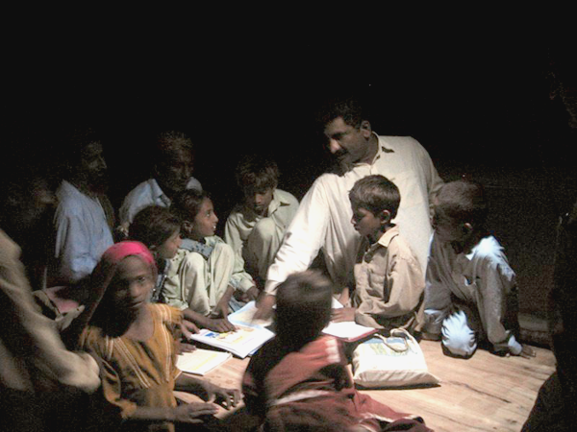 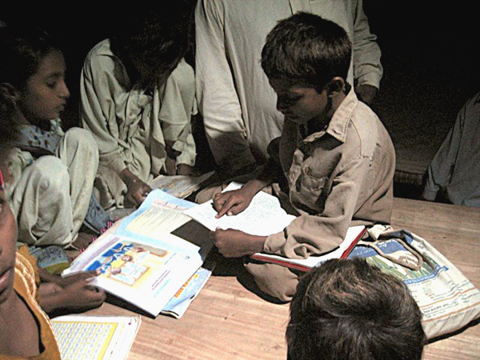
Village Children being set up under the light from the 3-Watt One of the Village boy performs test reading under LED Light.
Energy 65 degree beam LED Reading / Task Light Bulb. The The light level measured at on the book is 5.6 foot candle.
Illumination at the table level is around 5.6 foot candle

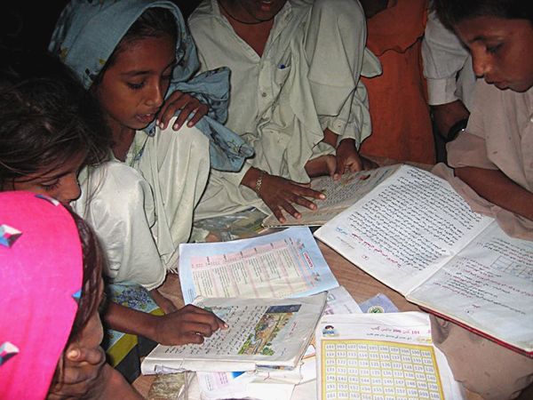
The village Girl is test reading her books under LED light.
Light level on the books is around 5.6 foot candle.

CONCLUSION

Following the tests we met with village committee members to discuss the lamps. They said that they were very happy because the light of new lamps, especially the 3-Watt energy 110-degree wide beam LED lamp demonstrated in the village meeting area, was very good. They also said that these lamps were blessing from Allah. Light of the lamps was much better, and met their expectations.

